Rayat Shikshan Santha’s
Azad College of Education, Satara
Report
Educational tour.
B.Ed 2nd year.
(2023 - 2024)
Head Of Department - Mrs. Patil S. S

Index
Sr.No | Components
1 | Introduction
2 | Objectives
3 | Information of spots -
4 | Vijapur
5 | Almatti
6 | Kudalsangam
7 | Badami
8 | Conclusion

Objectives.

- Reinforce experimental and contextual learning.
- Development of management skills
- Develope critical thinking.
- Academic Augmentation.
- Better perspective.
- Build social skills.
- Create lasting memories.
- Culture.
- Boost confidence.
- Communication.
- Enhance knowledge and understanding.
- Enhance learning.
- Experimental learning

Introduction

Rayat Shikshan Sanstha's, Azad College of Education Satara, under B.Ed syllabus an educational tour was organised by tour department dated on 4 th and 5 th March 2024, at Karnataka. Educational trips serve many purposes including enhancing learning, promoting social and emotional development and exposing students to real life situations .Educational tours helps teachers in broadening the scope of their syllabus .
They bring to the classroom enthusiasm and a New found energy.Tour wich focus on education allow teacher to connect the classroom with the outside world . The main purpose of the educational tour for B.Ed students is to give them experience of management, organisation of the tour as they are going to become teachers.
On Monday, 4th March journey of students of B.Ed 2nd year and their teachers has started at 4:00 a.m. from Azad College of Education Satara. After complete travelling of about 5 to 6 hours all have reached at vijayapur Karnataka which was our first destination. First spot of the tour was Vijapur fort.
Vijapur fort-
It is a very big fort with many structures inside. The fourth was built in 1565 by the founder of the Adil Shahi dynasty. There are 96 bastions of various designs within the fort. Species were provided within the bastions to drops stones or canons.
After that nearly about 12:30 o'clock we reached at Golghumat.

Gol Ghumat-
It is the most famous monument in vijapur. It is the tomb of Mohammad Adil Shah. It is the second largest doome ever built, next in size only Stpeter's Basilica in Rome.A particular attraction in this monument is the central chamber where every sound is echoed times.
Muluk e maidan-
An intricately carved 16th century canon is considered one of the largest medieval guns ever made. Measuring 14 feet long and waging 55 turns, the canon wreaked havoc at the battle of talikota in 1565 and is now located in vijapur fort.
After that we moved towards Almatti and which was our last destination for 4th of March. All entered in almatti garden.almatti garden specially famous for its water fountain show.
Almatti Dam-
Almatti dam is the main reservoir of the upper Krishna irrigation project. The 290 MW power station is located on the right side of the almatti dam. The facility use vertical Kaplan turbines five 55 MW generators and one 15 MW generator.
At 7 pm water fountain show was started . Three show was conducted at that time. This show was the representative of various diversity in Karnataka. She was ended at 9:00 p.m. and all move towards hotel for dinner.
On 5th March our journey of this educational trip for second day was started at 6:00 a.m. all student teachers was ready for further journey. All has reached at Kudal Sangam..
Kudal Sangam -
In India it is important centre of pilgrimage for Lingayats.it is located about 15 km from dalmati dam in Bagalkoet district of Karnataka. The Krishna and mala Prabha river merge here and flow East towards srisailam.Andhra Pradesh. There is a beautiful temple of lord Shiva. Afterwards all visited to pattadakal.
Pattadakal -
It is also called as rokthapura .It is a complex of 7th and 8th century CE Hindu and Jain temples in Northern Karnataka located on the West Bank of the mala Prabha river in Bagalkot district.
After that we move towards Badami fort.
Badami fort -
Badami fort is a renowned archaeological site in Badami.it is located on top of a hill that stands at a distance of about 2 km from the main town of Badami in the Bagalkot district of Karnataka. The origin of the fort dates back to 543 AD. The ancient fort was built by the chalukyaan king pulakeshi.
Badami museum -
This is a very small museum with about 3/4 small rooms.one of the rooms cover general prehistory one covers the temples of Badami pattadakala and surrounding areas and has exhibits of Hindu sculptures. the museum is located at the foot of Badami fort in the village on the northern shores of agastya lake.
Badami cave temple -
The Badami cute temples represents some of the earliest known temples of Hindu temples in the Deccan region. They along with the temples in Ahiole transform the mala prabhari were valley into a cradle of temple architecture that influenced the components of letter Hindu temples else were in India. There are four caves..
And the last spot of educational tour was Banashankari Devi temple.
Banashankari Devi temple -
The temple attracts devotees from the Karnataka as well as neighboring state of Maharashtra. The temple celebrates its annual festival called Banashankari jatre, in the month of January or February the festival comprises cultural programs, boat festival as well as the ratha Yatra there are statues of Bhima Bhramariand Ganesha along with mother.
By this way all the student teachers visited decided spots of this tour. Near about 9:00 a.m. come back journey was started from Karnataka to Satara. All has reached at Satara about 6:00 a.m. morning on 6th of March.

Mulukh Maidan Toph
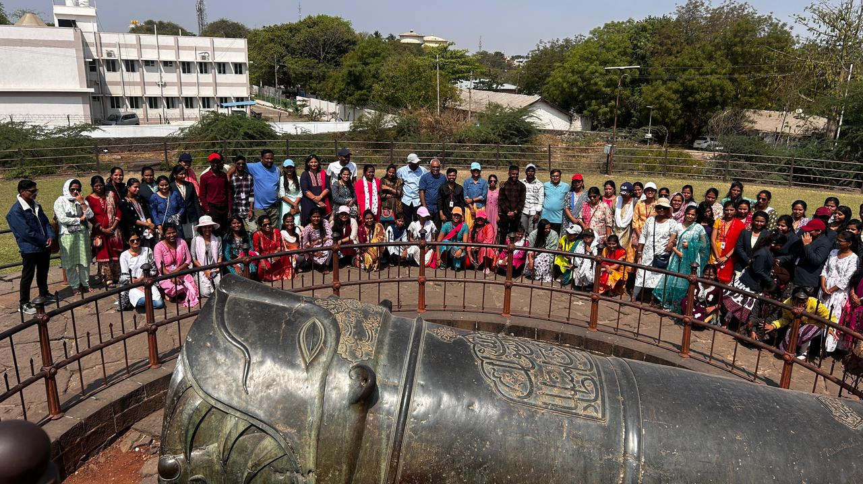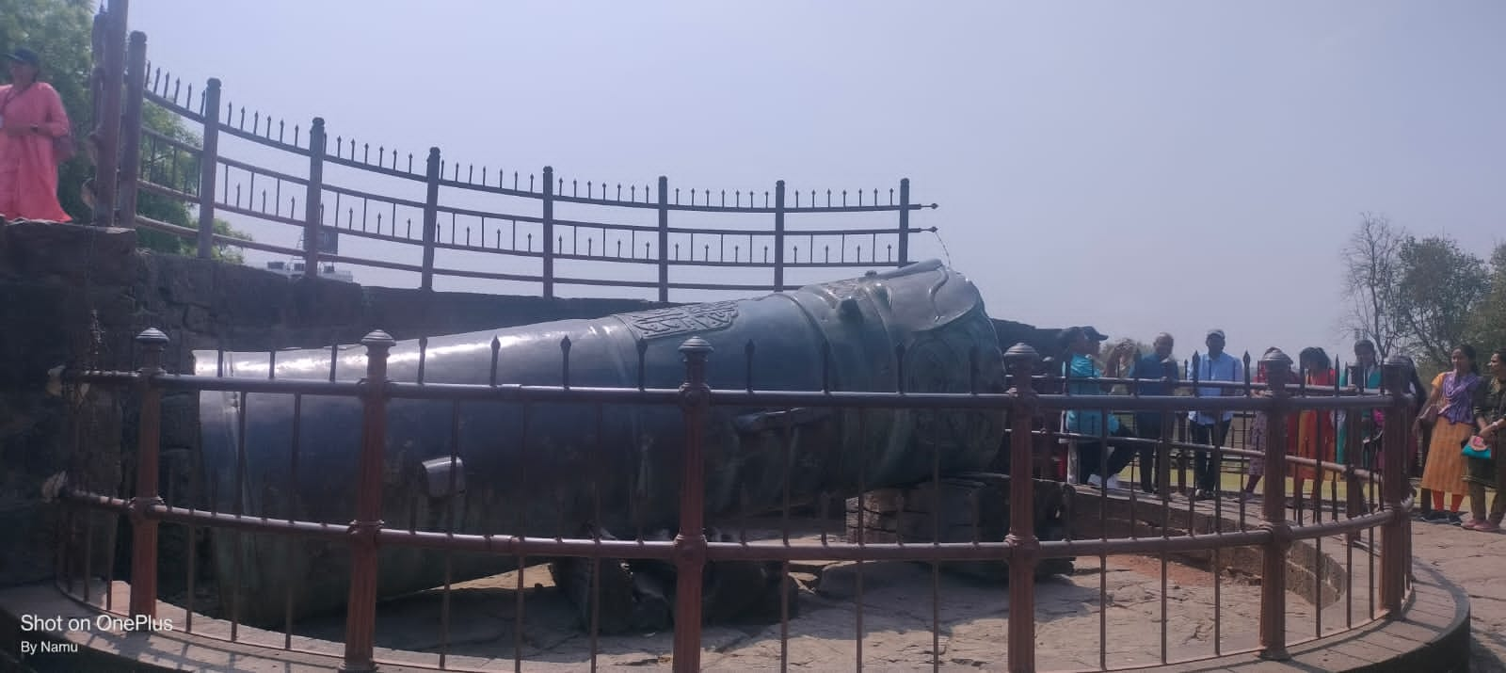

Gol Ghumat
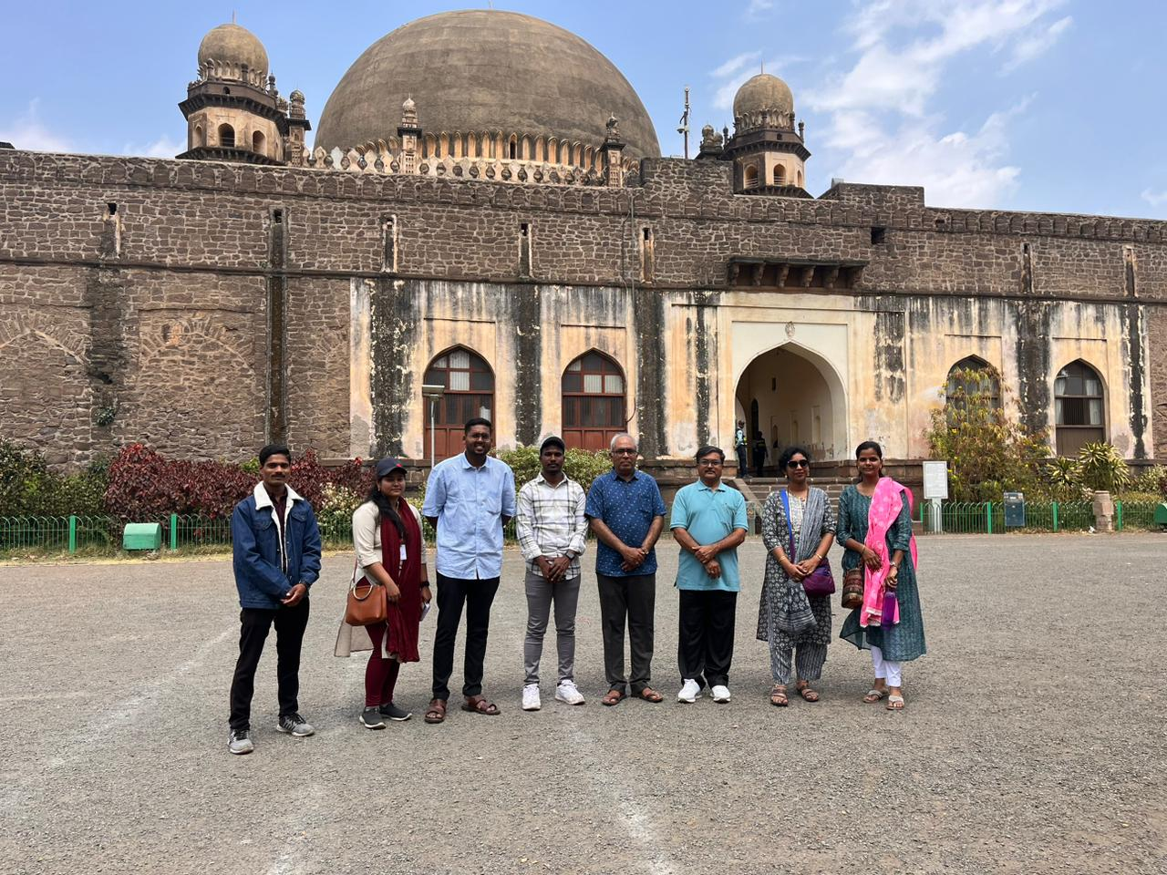
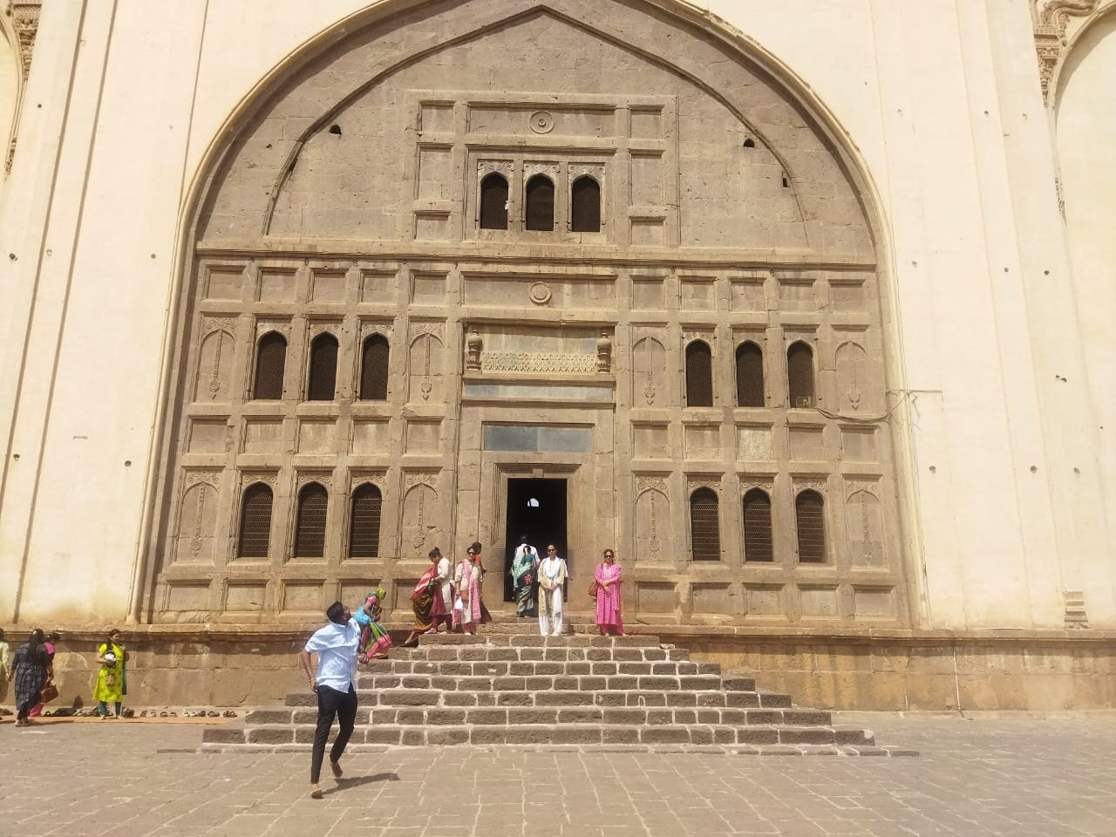
Almatti Dam
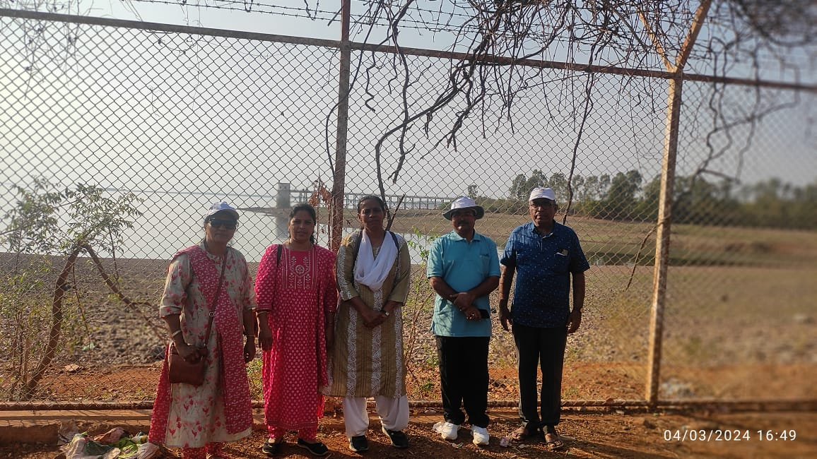
Almatti Garden
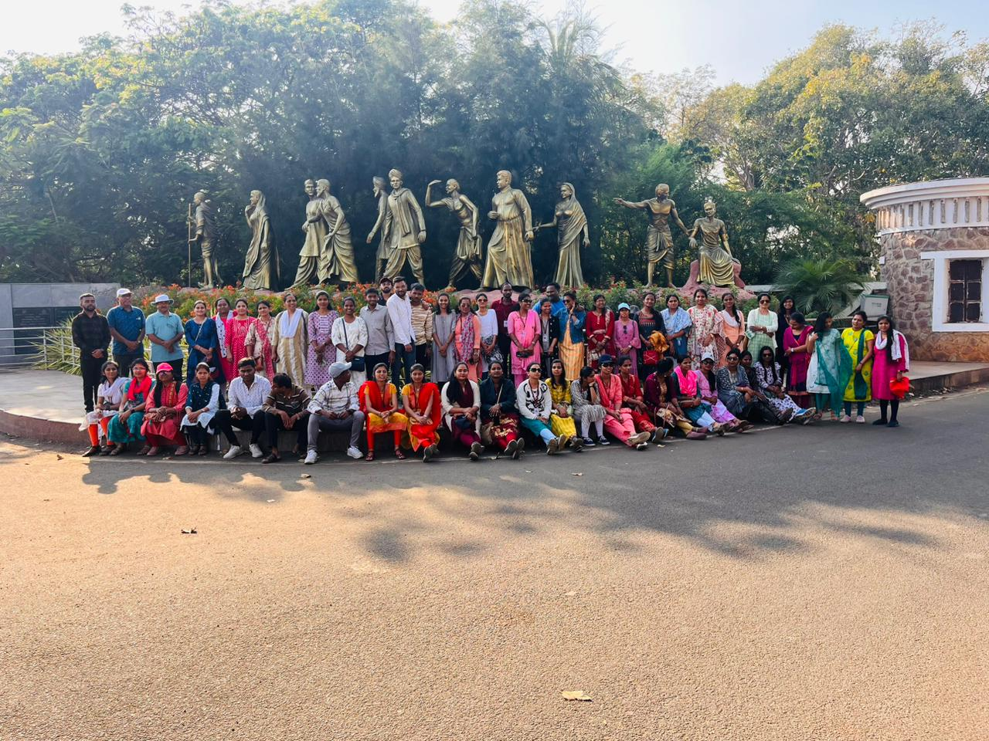
Badami Fort
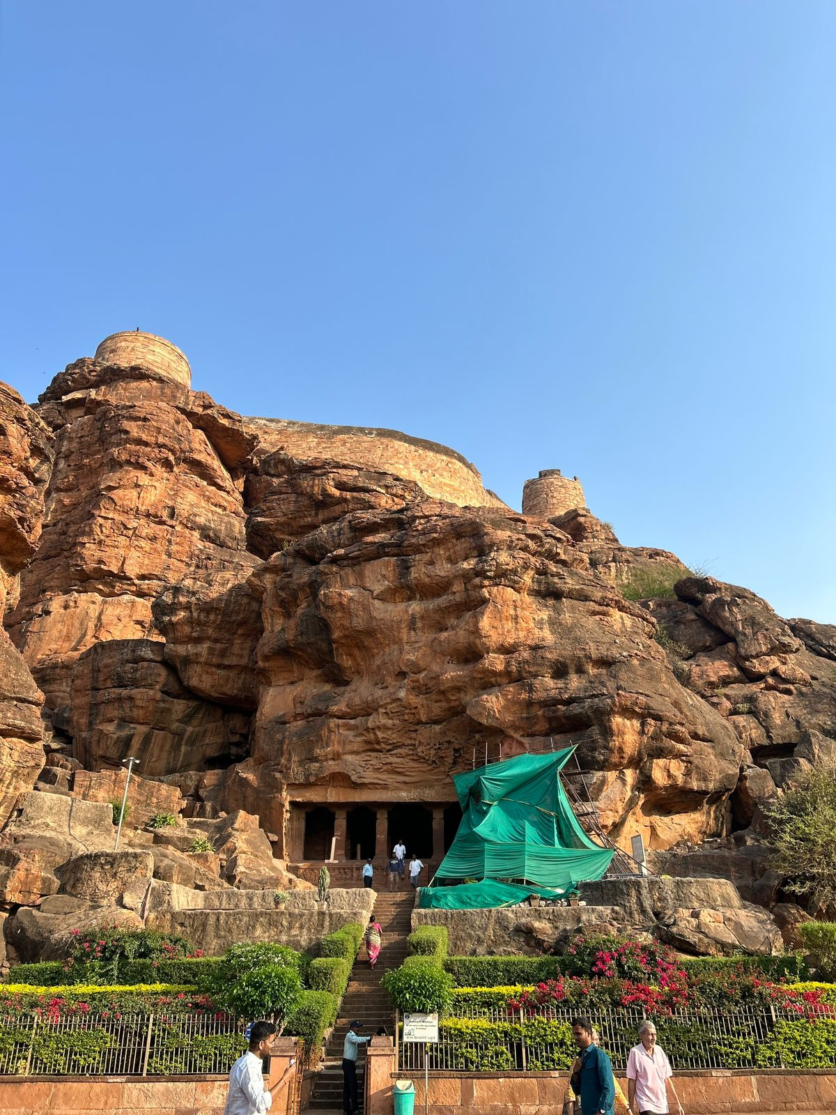
Badami Museum
